Lecture on Indian Space Programme Journey since independence
Dated 26-10-2021
Lecture on Indian ‘Space Programme Journey since independence’ was organised by Indian Institute of Remote Sensing ISRO (Indian Space Research Organisation) Department of Space GOI on 26th October 2021. The department of Geography under the leadership of Dr. Renuka Thapliyal arranged ICT facilities for students to attend this lecture. This lecture was a part of the series ‘Azadi ka Amrit Mahotsav’ and was attended by 48 students.

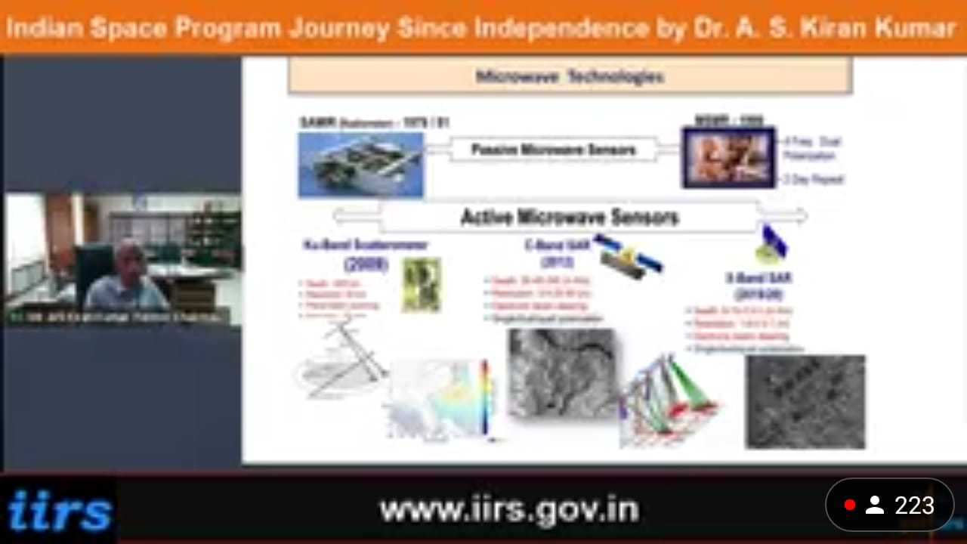

Dr. Renuka Thapliyal
Coordinator ISRO Outreach Programmes

